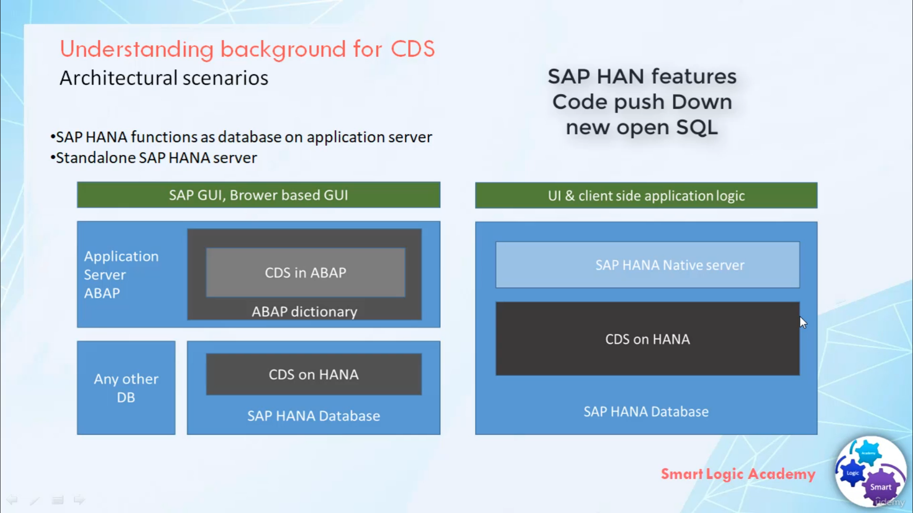

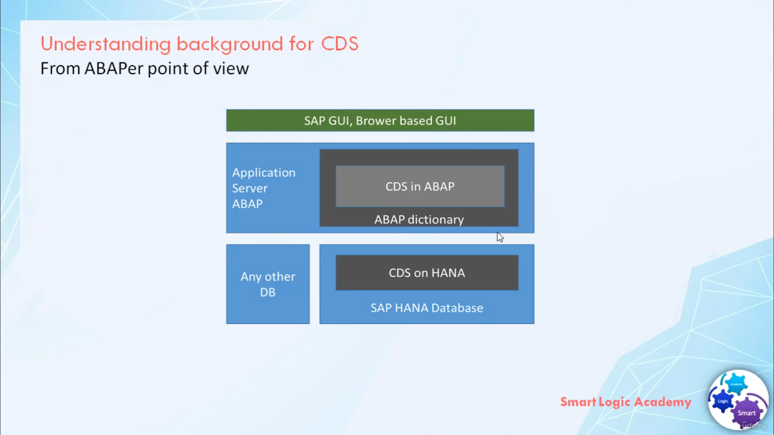

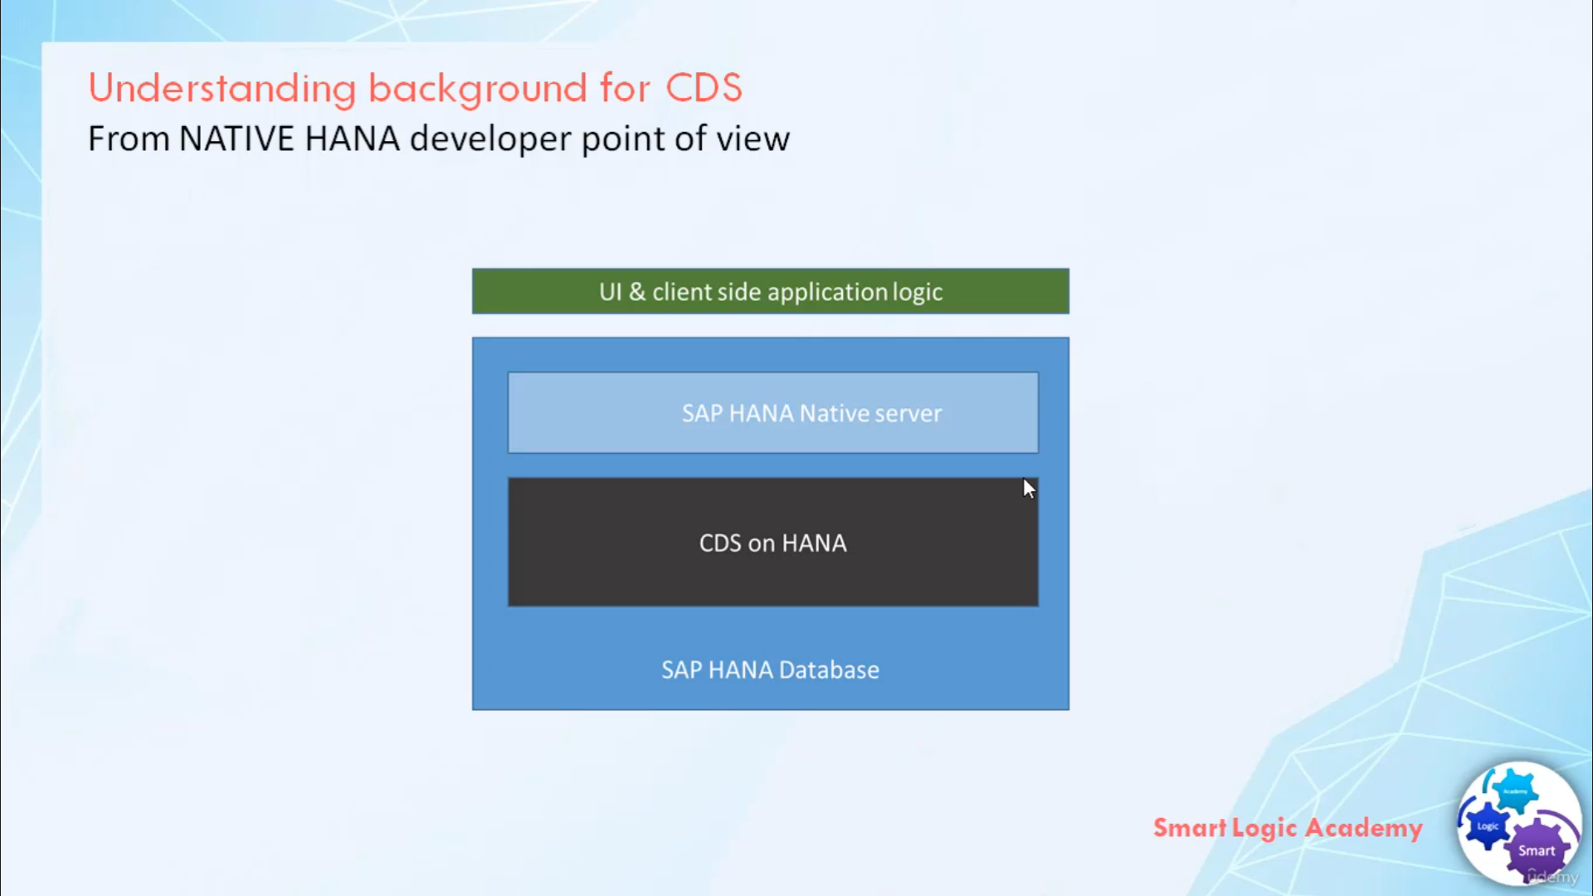

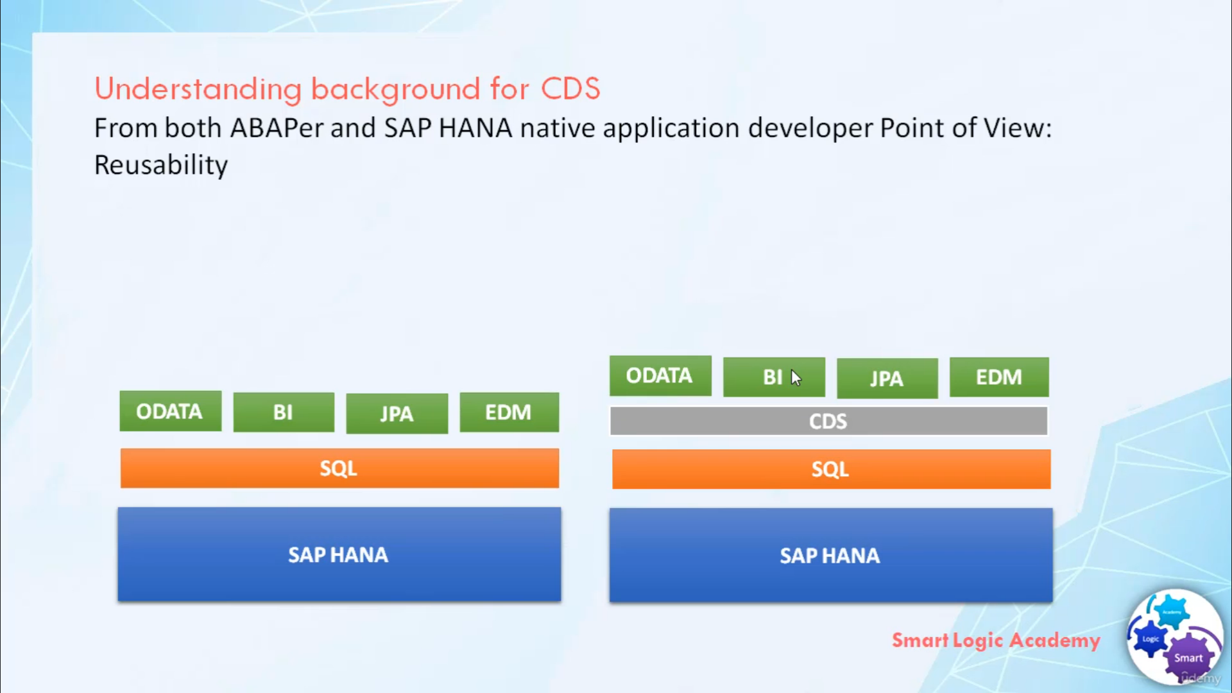

Hi,

welcome back.

I hope you understood the main features of SAP HANA, what is CODE-PUSH-DOWN approach and why there is a need

NEW OPEN SQL syntax.

Now based on the knowledge that we have gained till this point

I will explain to you the need for Core Data Services. So let's start, SAP HANA can be used in different

architectural scenarios, which in turn provides a technological base for different application areas.

So here the first diagram shows SAP HANA functions as a database and the second diagram shows standalone

SAP HANA server. As you can see, here

we have application server and SAP HANA as a database. Here in this diagram we don't have any application

server.

instead of that, we have SAP HANA native server in HANA database itself.

Now let's see, why there is a need for Core Data Services from ABAPer point of view.

To take advantage of SAP HANA for application development, to push down code to database layer and perform

all complex operations on database layer ABAPer needs tool so that they can define and consume objects on

database layer itself. Hence SAP introduces a new data modeling infrastructure known as Core Data

Services. With CDS data models are defined and consume on the database rather than on the application server.

Originally CDS

was available only in the design-time and run-time environment of SAP HANA.

Now the CDS concept is also fully implemented in SAP NetWeaver application server, enabling

developers to work in ABAP layer and with ABAP development tools

while the code execution is pushed down to the database. Now let's see, why there is need of CDS from

Native HANA developers point of view. With SAP HANA it is possible to develop applications directly

on a database and not using an application server anymore.

Hence there is a need to create a data model repository directly on the database. As with ABAP

dictionary on application server, there should be more in the box for you than using native SQL

a statement like CREATE TABLE and CREATE VIEW. Especially regarding the need for enriching pure technical

definitions with semantics and that's the one reason for SAP's Core Data Services.

Now let's see,

Why there is need of CDS Core Data Sevices from both ABAPer and

SAP HANA point of view.

Which is common for both ABAPer and SAP HANA native application developer.

SAP HANA supports SQL as a means to define and manipulate data.

On top of SQL, many technologies introduce higher-level models to add semantics and ease comsumptions

such as ODATA Open Data protocol, EDM Energy Data Management models, semantics layered in Business

Intelligence BI platform, JAVA persistence API JPA.

These high-level models share many commonalities but are usually specific to their technology.

This prevents their reuse across the stack and increases the effort for application developers, to address

these

SAP introduces a set of domain-specific languages and services called Core Data Services for defining

and consuming semantically rich data models.

CDS simplify and harmonize the way you define and consume your data models regardless of consumption

technology.

Technically it is an enhancement of a SQL which provides you with Data Definition Language for defining

semantically rich table, views and user-defined types in the database.